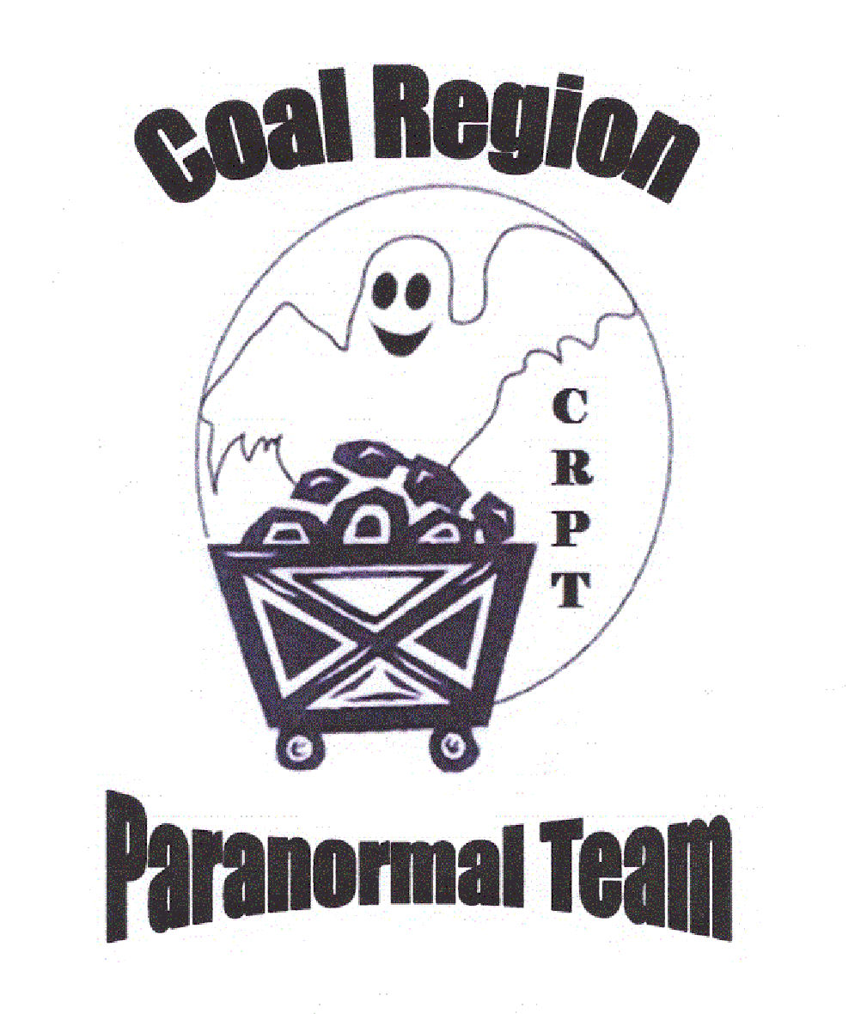 | INVESTIGATION REPORT  Case Number LAM-041412  Saturday April 14, 2012  7:30 pm Start Time
Client Information:
Leigh Ann Maurer
138 Walnut Street
Ashland PA 17921
570-933-5909
Investigation Team:
Lead Investigator Richard Rozell
 | Basement and 1st Floor | 2nd Floor and Attic
1 | Karen*, Angel, Gary | Dave*, Lisa, Megan
2 | Dave*, Lisa, Megan | Karen*, Angel, Gary
3
*Floor Leader * Third rotation will depend on activity and outcome of EVP session
GEOLOGICAL INFORMATION:
The Anthracite Upland Section consists of an upland that has low, linear to rounded hills, strip mines, and mining waste piles. The upland is surrounded by an escarpment, a valley, and a mountain rim. The dominant rock types are sandstone, siltstone, conglomerate, and anthracite coal and quartz crystals.
METEROLOGICAL DATA
Ashland, Schuylkill County, Pennsylvania (longitude W76.3, latitude N40.8):
Light Data:
Friday 14 April 2012 Eastern Daylight Time
SUN  Begin civil twilight 5:59 a.m.  Sunrise 6:27 a.m.  Sun transit 1:06 p.m.  Sunset 7:44 p.m.  End civil twilight 8:13 p.m. | MOON  Moonset 12:28 p.m. on preceding day  Moonrise 2:52 a.m.  Moon transit 8:09 a.m.  Moonset 1:33 p.m.  Moonrise 3:25 a.m. on following day
Phase of the Moon on 14 April: waning crescent with 37% of the Moon's visible disk
Last quarter Moon on 13 April 2012 at 6:50 a.m. Eastern Daylight Time
Weather:
Temperature  Low: 33.0 °F High: 70.0 °F | Humidity 49% | Precipitation: 0.00 In

.
Equipment:
Digital Cameras (1)
Digital Cameras with Night Shot (5)
Full Spectrum Camera (3)
Digital Video Cameras with Night Vision (3)
Digital Audio Recorders (6)
Digital Infrared Thermometers (3)
K II Meters (3)
EMF Meters (5)
Real-Time EVP Recorders (4)
Ghost Box/Spirit Box (3) (Experimental)
REM Pod (1) (Experimental)
Laser Curtains (1) (Experimental)
Ovilus (2) (Experimental)

Investigation Narritive:
Our team arrived at the location. Lead Investigator, Rozell secured the building and identified
the 1st floor Kitchen as the Command Center. Pictures were taken of the outside of the building for a baseline. The client briefed the team and updated them on occurrences in the home. The Team held an organizational to identify any operational changes and assign Teams and rotations for the evening.
The Teams were dispatched into their assigned areas where base line readings were taken and the teams began their investigation. The first and second rotations lasted approximately 1:00 hour per rotation with a fifteen minute between rotation for rest and to share information. A ten minute vigil was conducted at the beginning of each rotation An EVP session was conducted at the conclusion of the second rotation lasting approximately 30 minutes.

Base Readings:
Location | Temp | EMF
Basement | 69 degrees | .3 corner of living room.7
1st Floor | 70 degrees | .1-.4
2nd Floor | 72 degrees | .2-.4
3rd Floor Bedroom | UNKNOWN | UNKNOWN

Our team then compiled the information and evidence to review later. We spent the next few weeks reviewing, analyzing and reanalyzing what we believe was evidence.

Anomalies / Incidents Report:

EMF Fluctuation K2 readings. –
- None

EVP Analysis (Total of 40 hours of digital recordings) --
- None
Still Digital Camera Analysis- (Over 2100 total images reviewed)
This includes IR cameras, digital cameras, and full spectrum cameras
- None

Video Tape Analysis: (3 cameras, 12 hours of video reviewed)
- No significant Findings

Temperature Changes:
- None

Personal Experience:
- None
Experimental Equipment:

The devices listed here are new to the CRPT and still under “testing” conditions. That is until we can validate their effectiveness we will not rely on them as a sole source of proof, we cannot however totally discount any results they produce.

- Ghost Box:
- None
- REM Pod:
- None
- Ovilus:
  - None

Findings/Closure of Case:

Our team reviewed the evidence we captured on still digital cameras (standard, Infrared and full spectrum), audio EVP recordings, Video cameras with Night Shot capability and personal experiences.

We were unable to substantiate any of the claims of activity in the home on this particular evening.

Please do not misunderstand we are in no way questioning the reliability of the numerous reports of activity and the experiences of the residents of this home. We are only saying that based on the tangible evidence we were (or were not) able to gather on April 14, 2011 we cannot substantiate a haunting.

It is important to note that the third floor bedroom at the last moment was restricted by the home owner’s roommate who also refused to participate in the investigation. This was initially strange as this individual did participate in the interview and initial walk through just 2 weeks before. Further research seems to indicate that this individual may have been still participating in some form of ritualistic activities and may have “pulled out” of participation in the investigation at the last minute to avoid being discovered. The lack of access to this third floor room and the participation of this individual do leave the question of what would be found if total access was allowed.

In the future if access to the total house would be allowed the Coal Region Paranormal Team would be interested in returning and reinvestigating the residence, until then we can only restate that at this time we were unable to identify any evidence of Paranormal Activity.

If you have any questions, further requests or need for our services please call us at any time.

Respectfully Submitted,

FOR THE COAL REGION PARANORMAL TEAM

Richard S. Rozell, Lead Investigator
Coal Region Paranormal Team
Certified Ghost Researcher (IGHS)
Certified Paranormal Investigator (IGHS)

